TITLE OF PAPER
Author¹, Author²(full name and surname of the author and all co-authors)

Address (es):
Address of all authors
*Corresponding author: mail@mail.com, tel.: XXX, faculty / university name, postal code, city, state

Received: xx.xx.xxxx
Accepted: xx.xx.xxxx

ABSTRACT

The abstract should be written in the past tense, because it refers to work which was already done. Any equations and references are not allowed. It must state the main object, scope, findings, describe the methodology, summarize of the results and state of the principal conclusions. The abstract must be minimally with 100 words.

Keywords: word; word; word (3 - 6 words)

INTRODUCTION

Proceedings submitted to ICPMAT 2023 have to be based on original theoretical or experimental investigations and MUST be no longer than 6 pages.
The Technical committee takes no responsibility for injury and/or damage to persons or property resulting from matter of product liability, negligence or otherwise, or from any use or operation according to any methods, products, instructions or ideas contained in the material published herein.
Publication is expected to conform to the ethical standards.
If English in manuscript is difficult to understand, the technical committee will reject the paper without technical review until it is readable by the reviewer. Reporting experimental or theoretical research within the scope of the conference. The proceedings are reviewed by 2 people selected among technical committee members.

MATERIAL AND METHODS

Subtitle of material and methods

Materials and Methods should be described with sufficient details. Plagiarize significant portions of other manuscript even from own work published previously is not acceptable.

RESULTS AND DISCUSSION

Subtitle of results and discussion

This section may be divided by subheadings. It should provide a precise description of all experimental results, their interpretation, as well as the conclusions that can be derived.
Figures and tables must be numbered with Arabic numerals with clear and brief captions. The captions are placed below figures and above tables.
In order to be accepted original photographs and printouts should be of good quality (minimum 300 dpi) and in an acceptable format (TIFF, JPG save at maximum file size) with width dimensions 8 cm, or 4 cm. All figures will be printed black and white. Figures and tables must be mentioned in the text

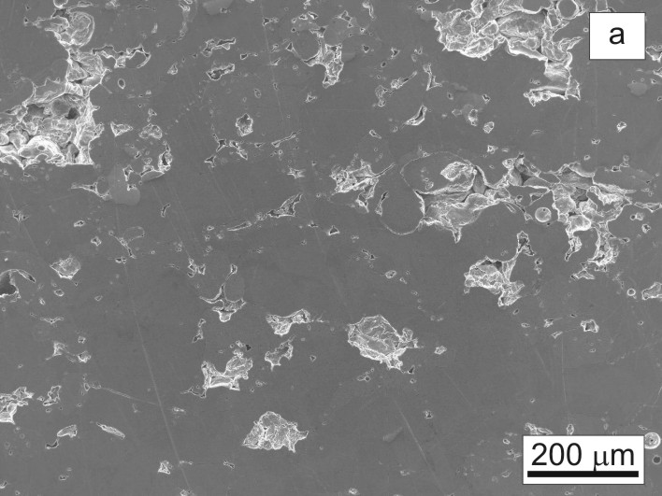
Fig. 1 Figure caption | Fig. 2 Figure caption

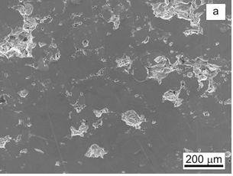
Fig. 3 Figure caption

An example of table is reported as follows:

Table 1 Amount of C and N in experimental samples
Samples | Average (wt. %)
Samples | C | N₂
AT1 – Ar | 0.520±0.04 | 1.015±0.04
AT2 - Ar | 0.035±0.04 | 0.020±0.04
AT2 – Vac | 0.235±0.04 | 0.025±0.04
AT3 – Vac | 0.255±0.04 | 0.965±0.04

Tables can also be included into a one column format as shown in the following:

Table 2 C content in different solutions
No | Samples | Concentration | AT1 |  | AT2
No | Samples | Concentration | XXX | YYY | ZZZ | KKK
1 | X1 | 10 | 7.5 | 9.5 | 7.0 | 10.0
1 | X1 | 20 | 8.5 | 10.0 | 9.0 | 14.0
1 | X1 | 30 | 9.0 | 11.5 | 10.5 | 17.0
1 | X1 | 40 | 10.0 | 11.5 | 12.0 | 18.0
1 | X1 | Control | 0 | 0 | 0 | 0
2 | X2 | 10 | 10.5 | 10.0 | 7.0 | 23.0
2 | X2 | 20 | 12.0 | 12.5 | 7.5 | 24.5
2 | X2 | 30 | 12.5 | 14.0 | 7.5 | 30.0
2 | X2 | 40 | 13.0 | 14.5 | 9.0 | 27.5
2 | X2 | Control | 0 | 0 | 0 | 0
3 | X3 | 10 | 8.0 | 6.0 | 9.5 | 7.0
3 | X3 | 20 | 10.0 | 13.5 | 10.0 | 9.0
3 | X3 | 30 | 14.0 | 13.0 | 10.5 | 11.0
3 | X3 | 40 | 14.0 | 16.0 | 11.5 | 10.0
3 | X3 | Control | 0 | 0 | 0 | 0
4 | X4 | 10 | 8.5 | 7.0 | 9.0 | 9.5
4 | X4 | 20 | 9.0 | 8.0 | 8.0 | 9.5
4 | X4 | 30 | 10.0 | 9.0 | 8.5 | 10.0
4 | X4 | 40 | 11.0 | 9.0 | 10.0 | 8.5
4 | X4 | Control | 0 | 0 | 0 | 0

Equations/formulae should be written in the following format:

$Z=\overset{˙}{ε}⋅\text{exp}\left(\frac{Q_{D}}{R⋅T}\right)$ (1.)

where: Z [s⁻¹] – Zener-Hollomonov parameter
$\overset{˙}{ε}$[s⁻¹] – strain rate
Q_{D} [kJ/mol] – activation energy of deformation
R [kJ/(K⋅mol)] – universal gas constant
T [K] – temperature

CONCLUSIONS
Conclusions must be comprehensive and not written like a report.

Acknowledgments: Authors are grateful for the support given by…

REFERENCES
The references must be from verifiable source and preferably from SCOPUS or Web of Knowledge database. References must be numbered serially. In the text refer to them by a number in square brackets [10, 15, 20-22]. Give the full reference in a list at the end of the paper (min. 20). There are essentially four types of reference entry: journals, books, conference proceedings and web side. They should be formatted as follows:
Journals: Names of all authors: full name of journal, volume, number (special issue, issue), year, pages. doi (if available)
Note: if Names of authors are more than 6, use: Name 1 author et al.: full name of journal, volume, number (special issue, issue), year, pages
Books: Names of all authors: title of book, edition, city: publisher, year
Note: if is Chapter of book, Names of all authors: title of chapter, title of book, editors, city: publisher, year, pages, doi (if exist)
Conference Proceedings: Names of all authors: title of article, name (only) of conferences, place, publisher (or editor), volume (if applicable), year, pages, doi (if exist)
Names of all authors: title of article, name of conferences, place, publisher (or editor), CD-ROM (number of articles, pages), year
Web side: As a minimum, the full URL should be given and the date when the reference was last accessed. Some further information, if known (Names of all authors, title, reference to a source publication, DOI, etc.), should also be given.
1. G. Adaikalaraj, R. D. Patric, M. Johnson, N. Janakiraman, A. Babu: Asian Pacific Journal of Tropical Biomedicine, 2(2), 2012, S1077-S1080. https://doi.org/10.1016/S2221-1691(12)60364-5
2. D. Manfredi, R. Bidulsky: Acta Metallurgica Slovaca, 23(3), 2017, 276-282. https://doi.org/10.12776/ams.v23i3.988
3. M. Besterci: Dispersion-strengthened aluminium prepared by mechanical alloying, first ed., CISP, London, 1999
4. T. Kvačkaj, J. Bidulská, R. Kočiško, R. Bidulský: Effect of Severe Plastic Deformation on the Properties and Structural Developments of High Purity Al and Al-Cu-Mg-Zr Aluminium Alloy. In.: Aluminium Alloys, Theory and Applications, edited by T. Kvačkaj, R. Bidulský, Rijeka: InTech, 2011, p. 3-26, https://doi.org/10.5772/14425
5. J. M. Martín, B. Navarcorena, I. Arribas, T. Gómez-Acebo, F. Castro: Dimensional Changes and Secondary Porosity in Liquid Phase Sintered Al Alloys, In.: Euro PM 2004, Wien, EPMA/Shrewsbury, Vol. 4, 2004, p. 46-53

Appendix
The appendix is an optional section that can contain details and data supplemental to the main text

